Create database in MYSQL by copying content from “DB.txt” file and paste in MYSQL

Now double click on ‘run.bat’ file to start python server and get below output

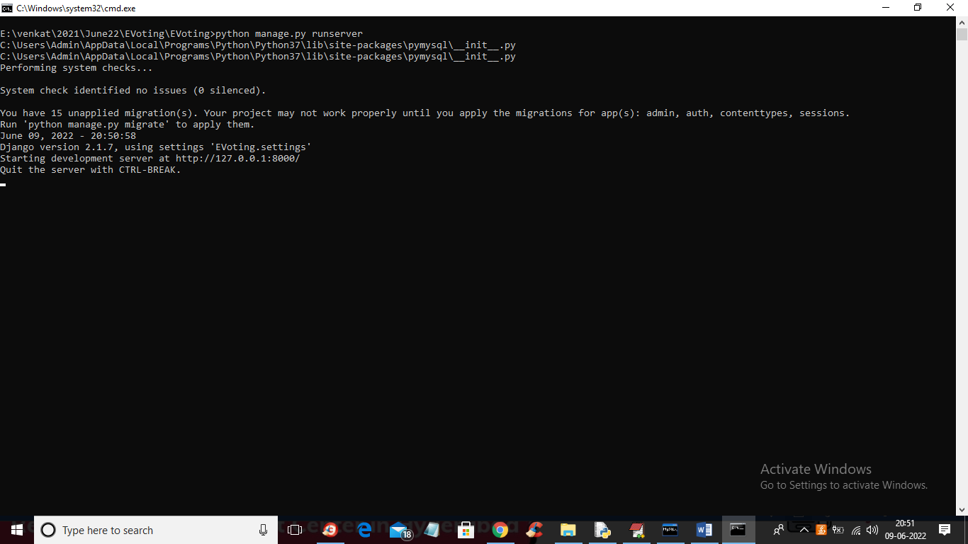

In above screen server started and now open browser and enter URL as <http://127.0.0.1:8000/index.html>’ and press enter key to get below output



In above screen click on ‘Admin Login’ to login as admin and get below screen

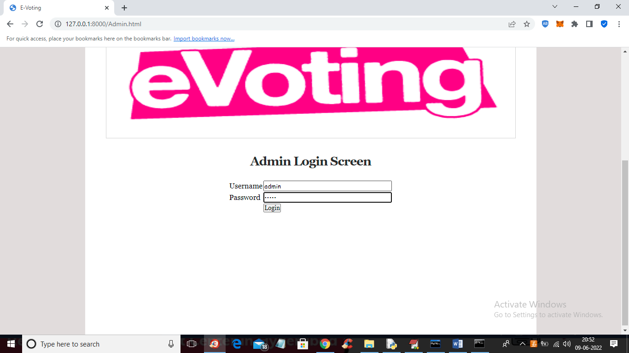

In above screen admin is login and after login will get below screen

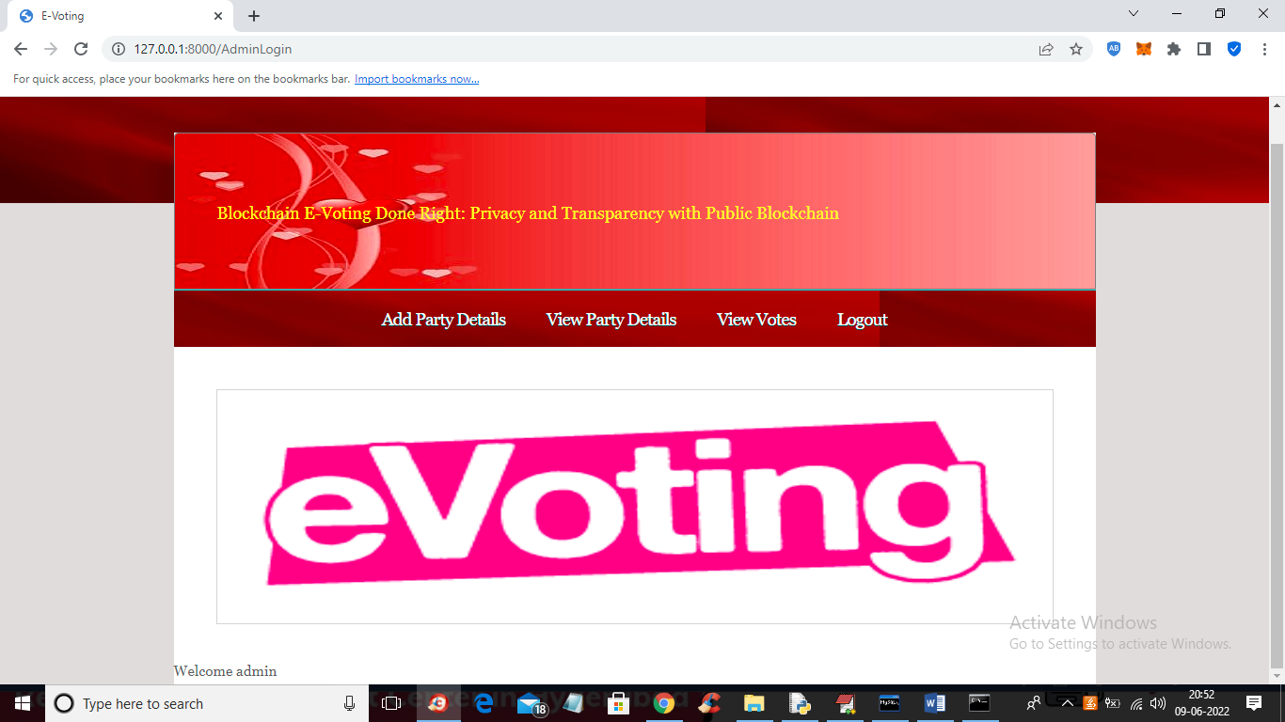

In above screen click on ‘Add Party Details’ to add new party details

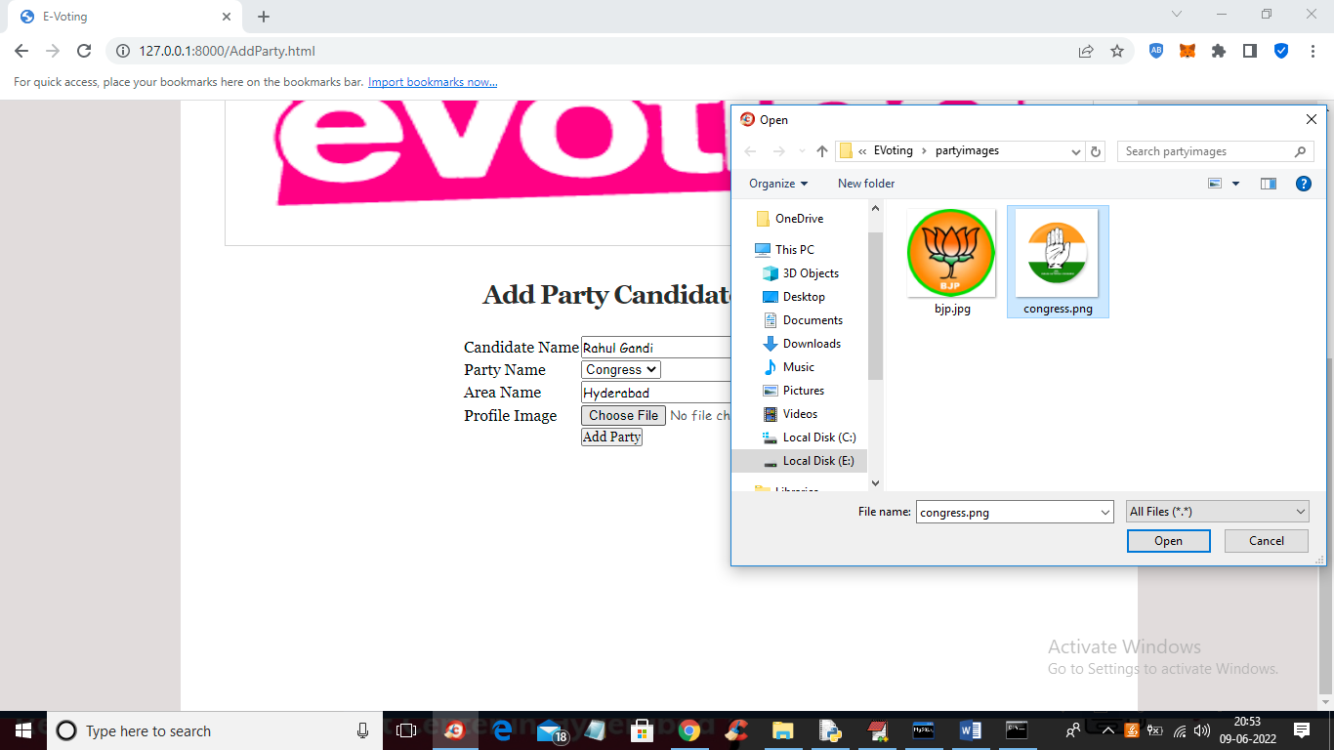

In above screen add candidate details with party photo and press ‘Add Party’ button to add new party and now click on ‘View Party Details’ to view all parties

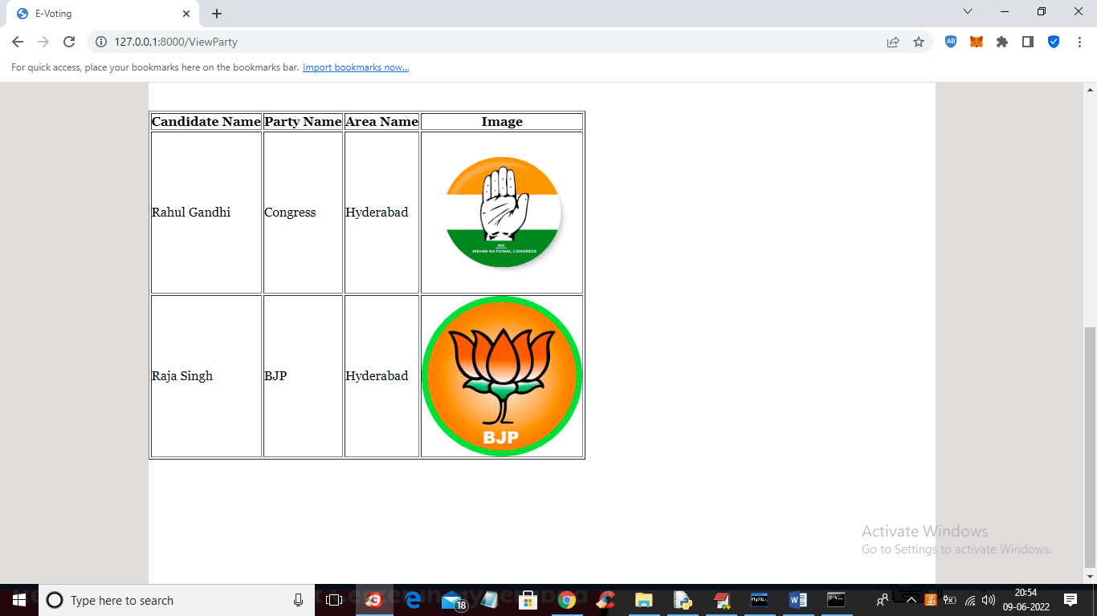

In above screen we can see all party details and now click on ‘View Votes’ link to get below output

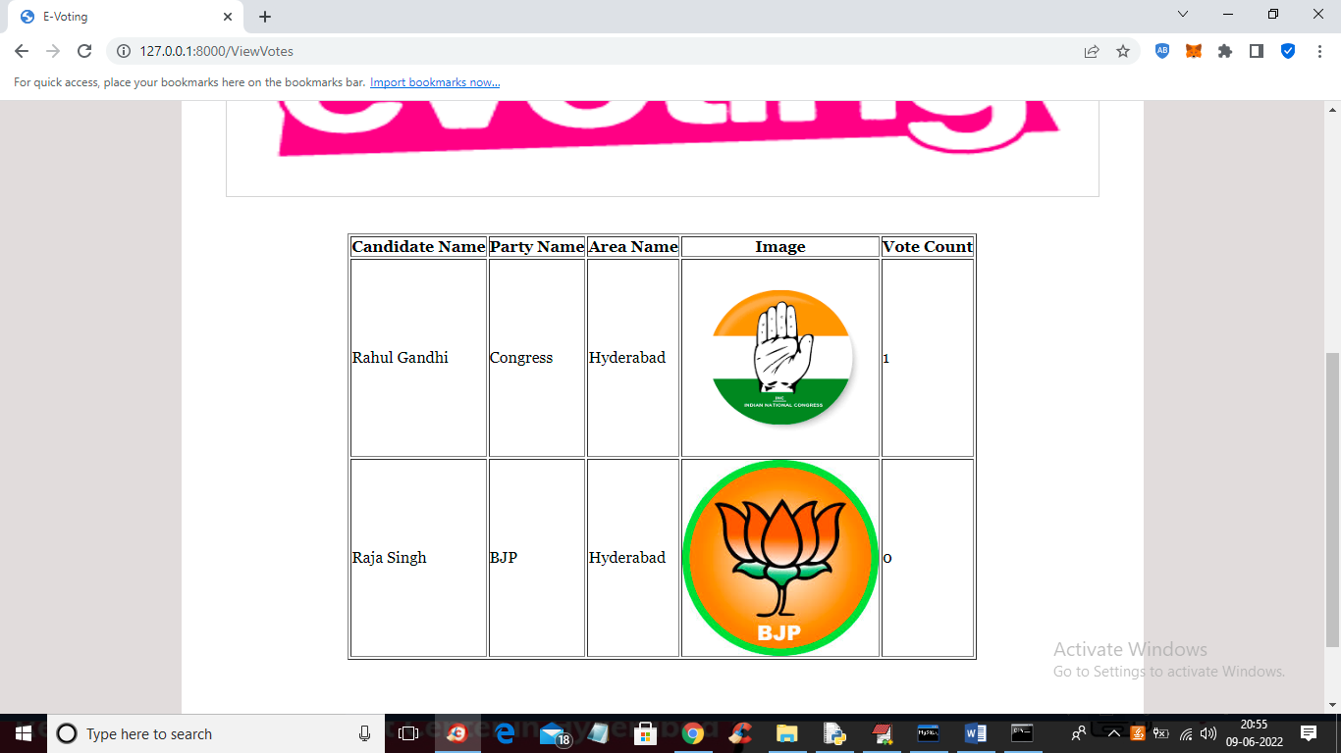

In above screen we can see vote count and now logout and signup new user like below screen

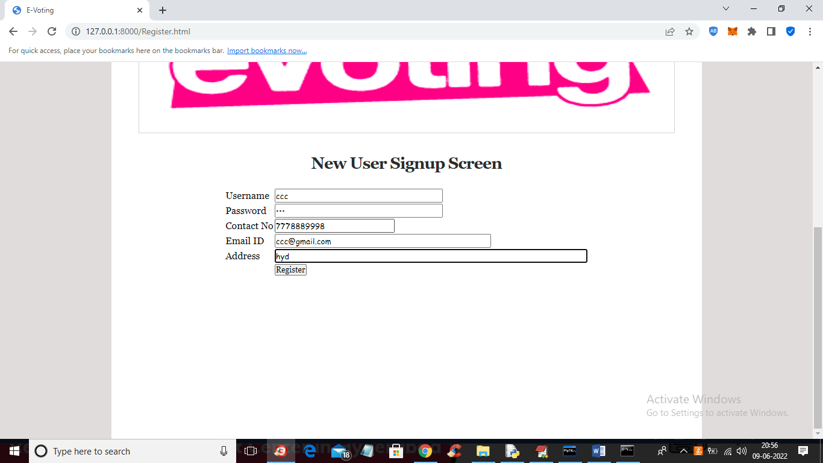

In above screen add new user details and then press ‘Register’ button to get below screen to capture user photo like below screen

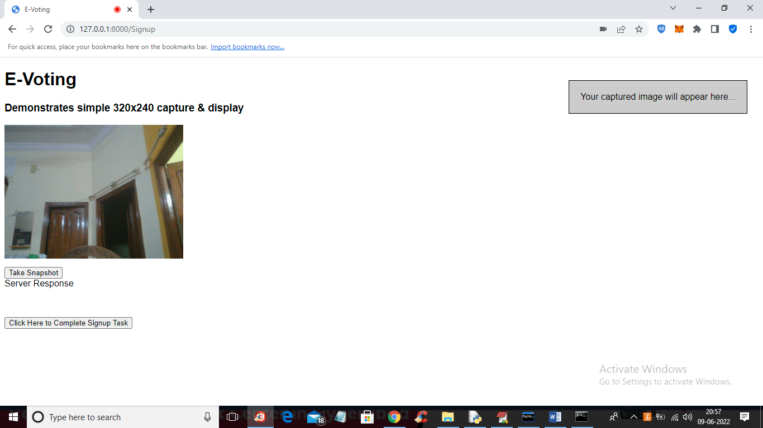

In above screen click on ‘Take Snapshot’ button to capture photo and get below output

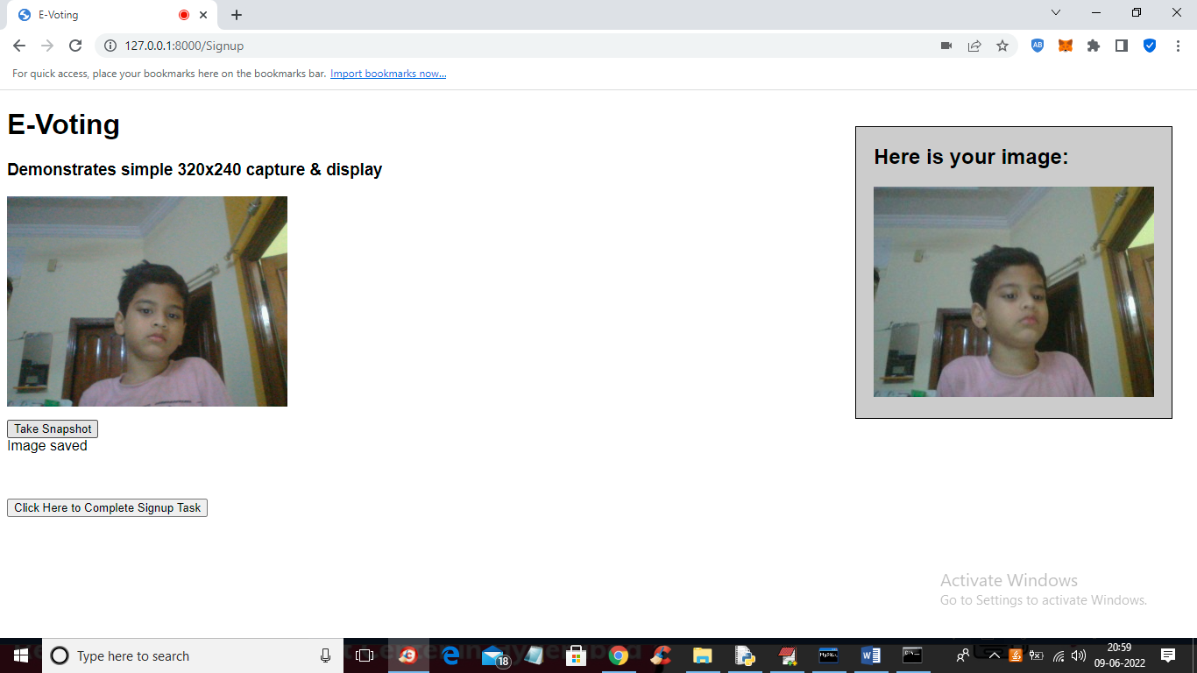

In above screen user image is captured and now click on ‘Click Here to Complete Signup Task’ button to save image in database and get below output

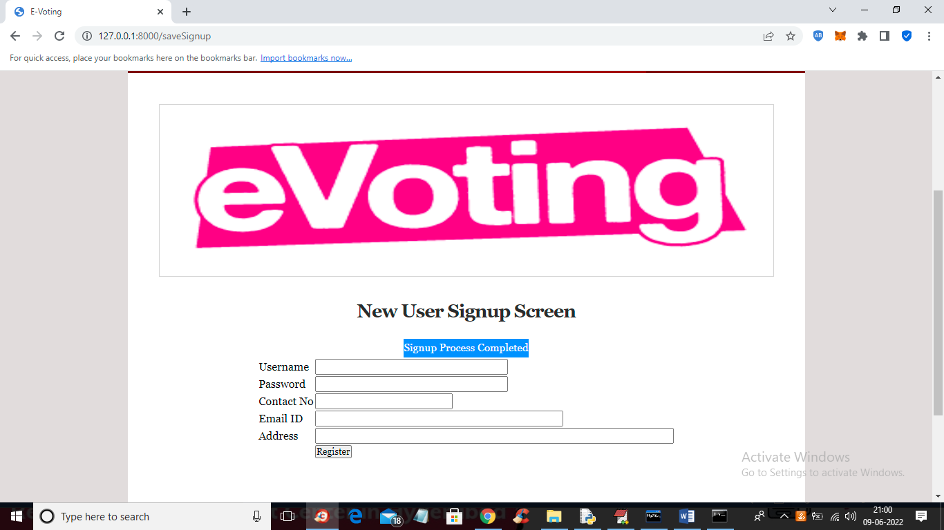

In above screen signup task with user image is completed and we can see all user images inside ‘static/profiles’ folder. Now click on ‘User Login’ link to get below login screen

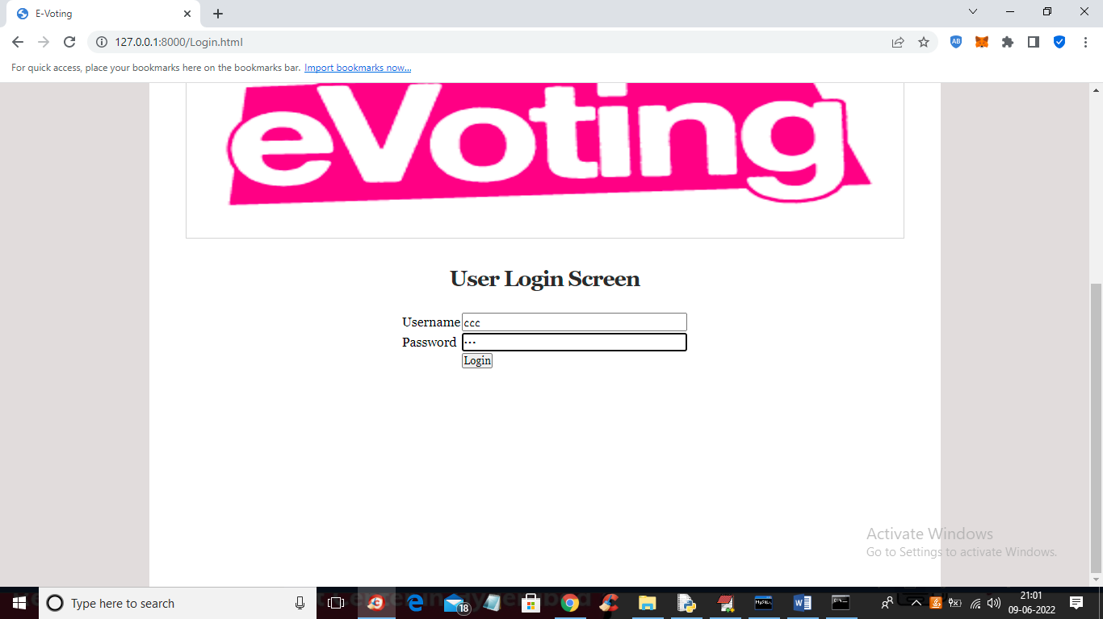

In above screen user is login and press button to get below output



In above screen click on ‘Cast Your Vote’ link to get below screen

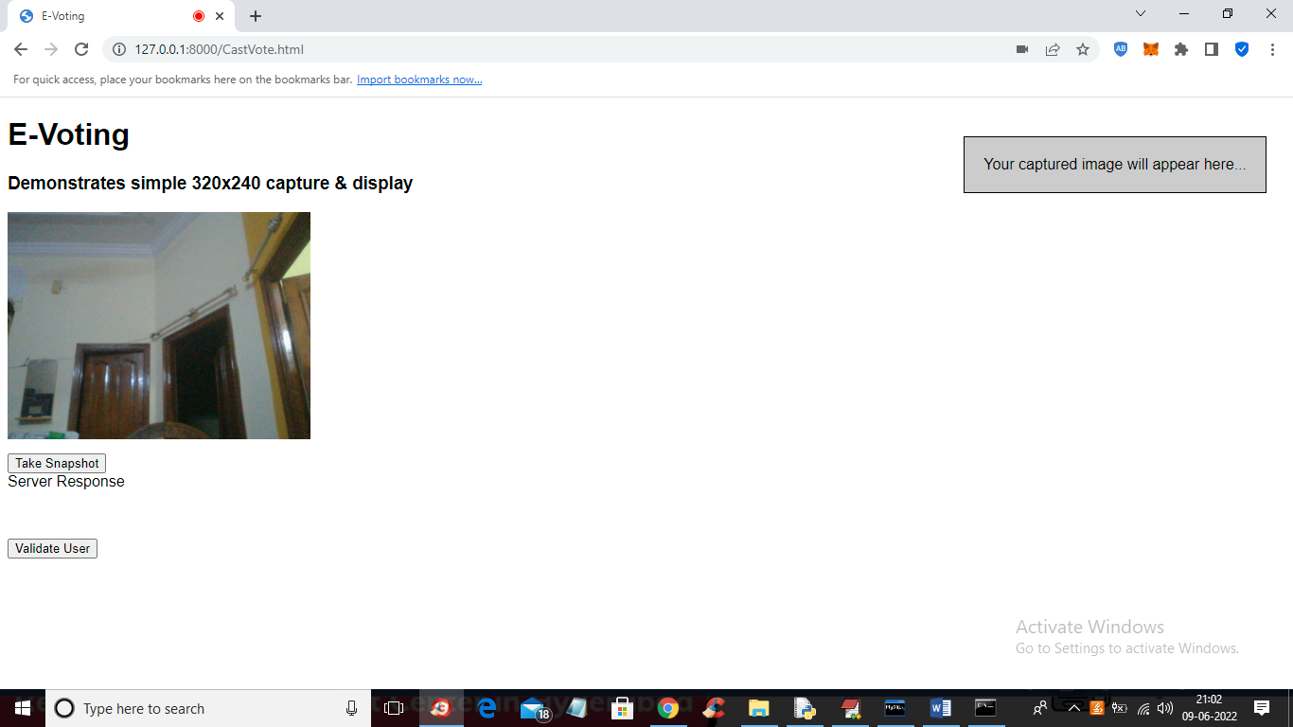

In above screen to cast vote click on ‘Take Snapshot’ and press ‘Validate User’ button to get below output

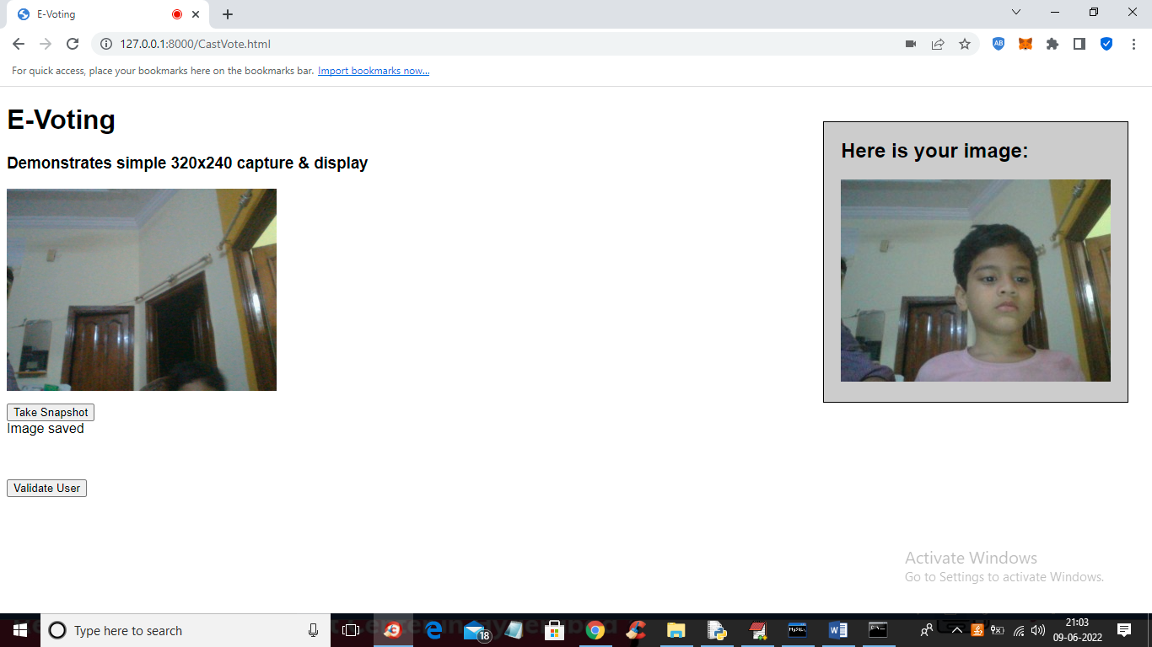

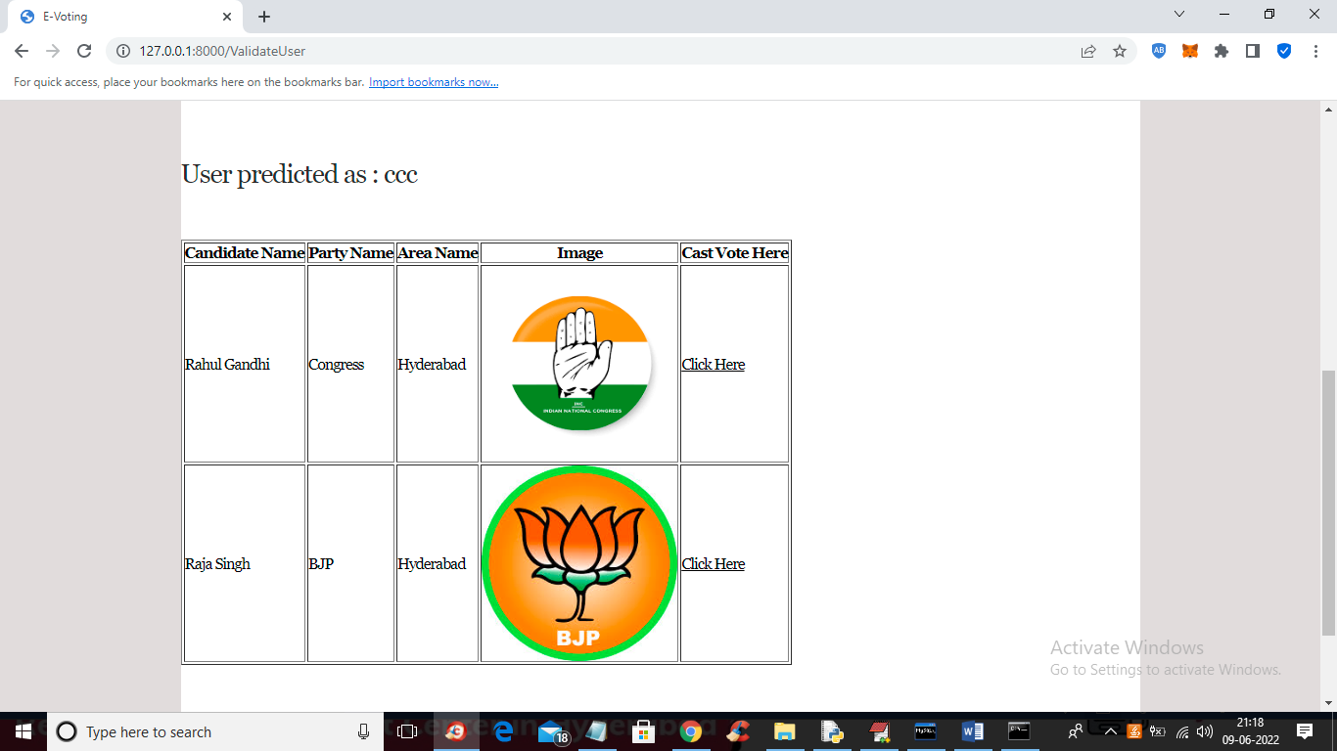

In above screen ‘User predicted as ccc’ and he can view all the party list and cast vote by clicking on ‘Click Here’ link and get below output



In above screen vote is accepted and if same user try again then will get below error output

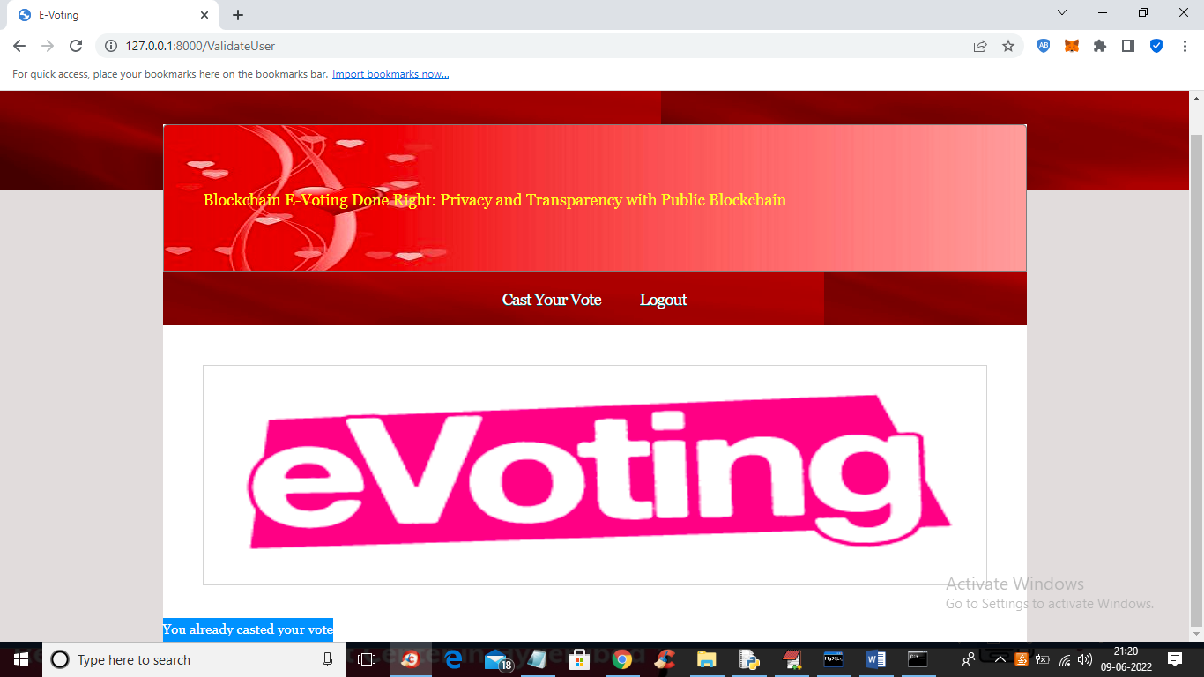

In above screen in blue colour text we can see ‘Vote is already casted by this user’ and similarly you can register and cast vote.

Note: this is computer program to recognize face so this application will correctly predict 6 out of 10 times